St Helens and Knowsley Teaching Hospital NHS Trust Immediate DIEP/OncoPlastic Services Referral Proforma
Please provide as much information as available
*Patients details:(Stick Addressograph)
Date: ……………………………
…………………………………………………………… Referring Consultant:…………………………
…………………………………………………………… Referring Clinician: ……………………………
…………………………………………………………… Breast care Nurse………………………………
Hospital: ……………………………………………

*Diagnosis: …………………………………………………………………………………………………………..

*Reason for referral: Consideration for (Please Circle/ Tick)
Mastectomy & Immediate Reconstruction for Right / Left / Bilateral
Delayed Reconstruction for Right / Left / Bilateral
Other………………………………………………………………………………………………………...
*Discussed with specific Whiston Consultant:
Breast………………………Plastics…………………….. Not discussed………………….
Referring consultant requesting to attend for Mastectomy? Yes/No
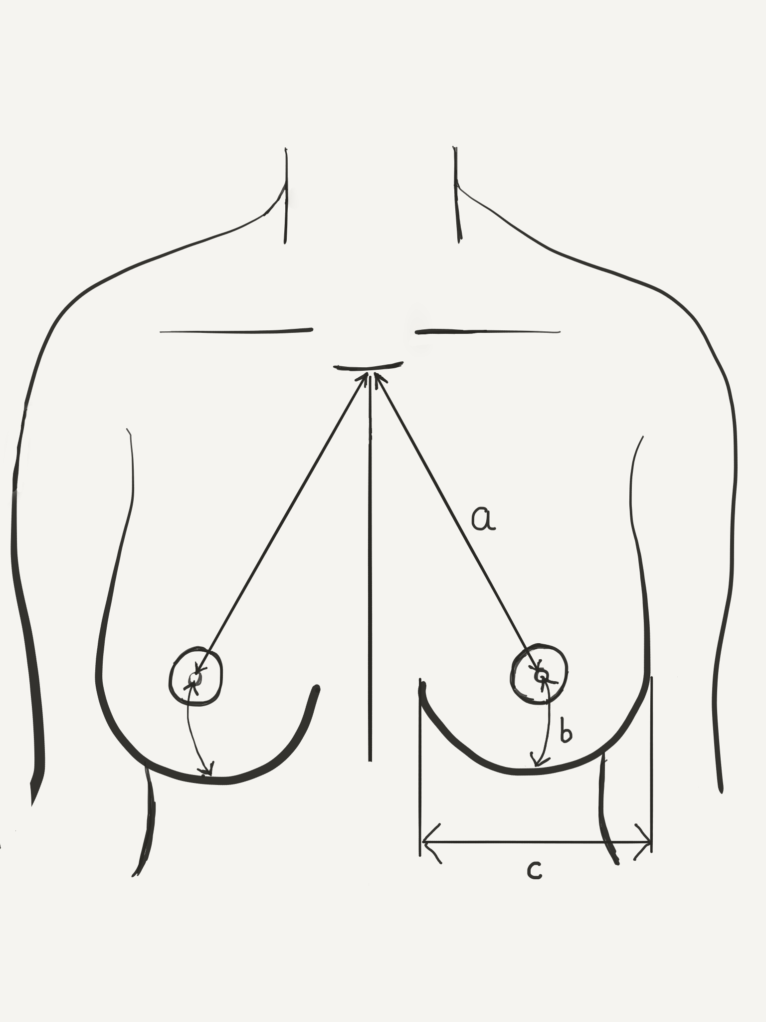
Patient Background:
Performance Status:
Height Weight *BMI
Current Bra size worn: ……………………… Asymmetry :
Smoker*: Yes / No Stop date: ………………Never
Diabetes Yes / No Type 1 Type 2
Medication…………………………………………………………………………
Other co- morbidities…...……………………………………………………
*Surgery performed to date:
AXILLA: Sentinel node biopsy Clearance
BREAST: Core Biopsy / Wide Local Excision / Mastectomy
Side: …………. Date:……………….
Specimen weight : …………………..grams

*Histology: Please attach all histology reports
*Staging scan performed (please tick):
CXR CT chest/abdomen/pelvis Bone scan Echocardiogram
Other
ECHOCARIOGRAM report – please attach
*Additional treatment received or planned
Chemotherapy Yes / No Planned ………………… Completion date……………………
Radiotherapy: Yes / No /Planned Right / Left / Bilateral
Hormone therapy: Tamoxifen/ Aromatase inhibitor
Biological therapy: ……………………………………………….
Previous Reconstruction: Tissue Expander / Implant / Strattice / Ti-Loop/…………..:
Right / Left / Bilateral
Previous Breast Reduction / Mastopexy Right / Left / Bilateral
Other surgery…………………………………………………………………………………………………………
Risk Reducing discussion: Done / Awaiting / Not applicable
*Psychologist referral: (N/A)/ Yes report attached / Has been referred
*Genetic testing referral: (N/A)/ Yes report attached / Has been referred

Patient Targets:
62 day target date if known:
Post-operative histology will be sent to referring trust for MDT discussion and patient consultation unless specified otherwise. Please inform if you would like us to take over care.

Please email completed form to appointmentssthk@nhs.net
This will be received by the Breast surgical team for clinical triage.

* MUST be completed prior to sending referral

