**PARAFRICTA BOOTEES**

**Each Parafricta Boot cost the Ward £45.**

**That is £90 for a pair**

**DO NOT DISPOSE**

**FRICTION & SHEAR PROTECTION**

**USED TO REDUCE CATEGORY 2 HEEL DAMAGE/BLISTERS**

 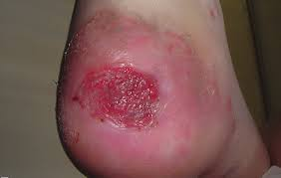

|  |  |
| --- | --- |
| **SMALL** | **4-6 UK Size** |
| **MEDIUM** | **6.5-8.5 UK Size** |
| **LARGE** | **9-11 UK Size** |
| **X LARGE** | **11.5-13 UK Size** |

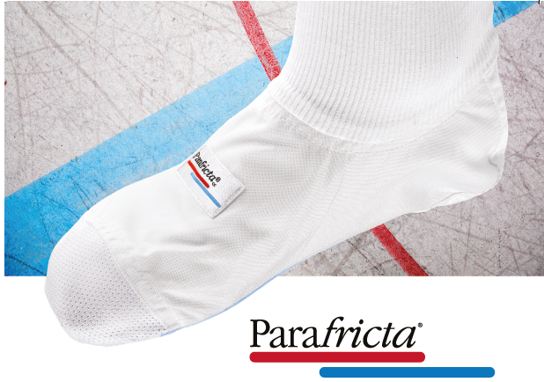

**TO BE APPLIED TO BED BOUND PATIENTS**

**Patient can be transfered from bed to chair only**

**Note:**

* Ensure they are removed regularly to inspect skin (feet)
* If patient is mobile with or without assistance then films need to be placed on heels. They do not require Parafricta
* Can be worn with dressings

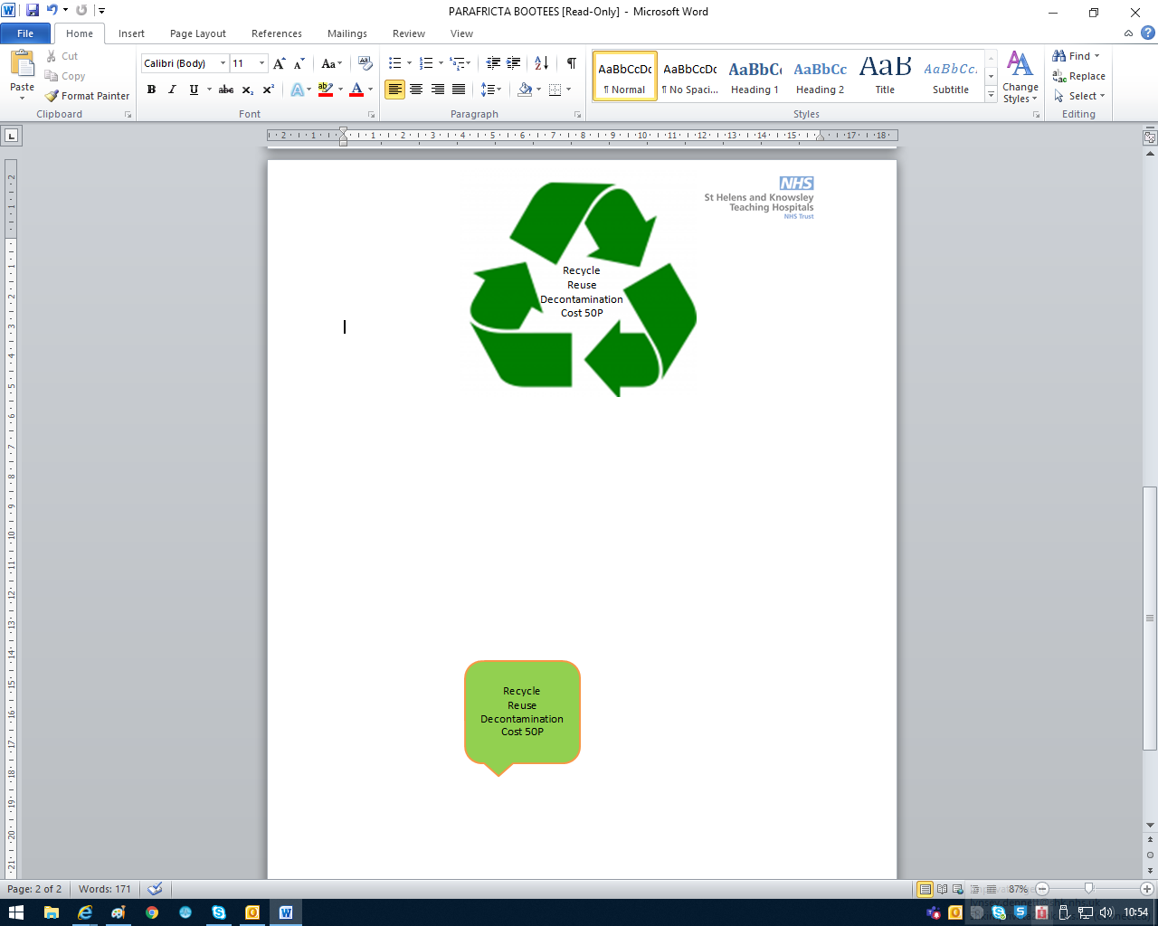Parafricta bootees can be obtained from the Equipment Pool (5th Floor), ensure that they are signed for in relevant book with patient name & ward.

When finished with Parafricta Bootees, they are to be red bagged and returned to dirty area of

Equipment Pool for

decontamination and re use

**Parafricta Bootees are reusabale once decontaminated**

**DO NOT DISPOSE**

**DO NOT SEND HOME WITH PATIENTS**