EQUIPMENT POOL
&
TISSUE VIABILITY TEAM
HI ALL
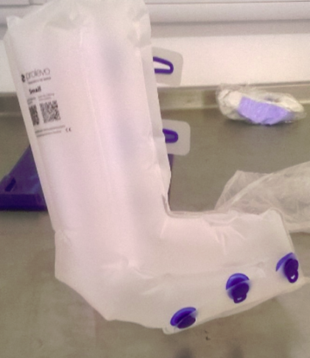
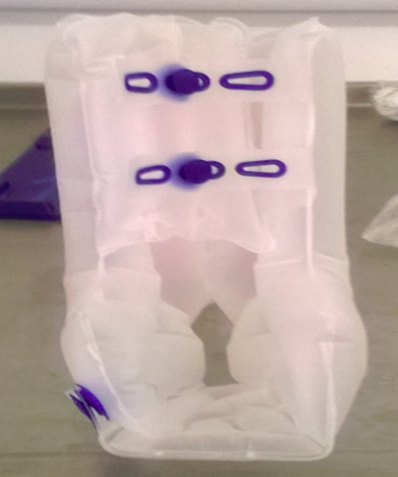
IF YOU HAVE ANY OF THESE INFLATABLE OFF LOADING BOOTEES ON YOUR WARD THAT ARE CURRENTLY NOT IN USE

PLEASE CAN YOU POSSIBLE SEND THEM BACK TO THE EQUIPMENT POOL IMMEDIALTELY AS THERE ARE NONE AVAILABLE TO ISSUE.

KIND REGARDS
LYNSEY DENNETT
EQUIPMENT POOL EXT 2323

