

**Referral for Paediatric Continence Assessment**

**Halton and St Helens**

***ALL*** *boxes must be completed to avoid referral being declined*

|  |  |
| --- | --- |
| **Childs Name:** Male/Female | **DOB:** |
| **NHS No:** |
| **Address & Postcode** | **Telephone Number:**  Home:  Mob: |
| **School/Nursery:** |
| **Parent/Guardian Name (must have parental responsibility):**    **Relationship to child:** |
| **Ethnic Origin:**  **Religion:** |

|  |  |
| --- | --- |
| **Reason for referral:**  **Please note - it is important that you provide information about what advice/strategies have already been given by universal health services and why it is felt the child now requires specialist support.** | |
| **Delayed toileting (from age 3 ½ years)** – (**never achieved continence) -** **Please also complete Appendix A (Toilet skills assessment)**  **Describe symptoms:**  **Strategies/advice given:** | |
| **Constipation**  **Describe symptoms:**  **Strategies/advice given:**  **Have they seen GP to initiate medication?** | |
| **Daytime wetting (From age 3½years**)  **Describe symptoms:**  **Strategies/advice given:** | |
| **Bedwetting (from age 5yrs only)**  **Describe symptoms:**  **Strategies/advice given:** | |
| **Soiling**  **Describe symptoms:**  **Strategies/advice given:** | |
| **Safeguarding Information (must be completed) – Social worker details MUST be provided below**  **Looked After Child Yes No**    **Child In Need/Child Protection: Yes No**  **Is there a CAF in place (send copy) Yes No**  **Domestic Violence? Yes No**  **If yes to any of the above, please give further information:** | |
| **Social Worker: Yes No**  **Name/base:**  **Contact Number:** | **Home Visit Concerns:** |
| **GP details (St Helens / Newton le Willows / Widnes / Runcorn only)**  **Address/Postcode:**  **Telephone Number:** | |
| **Is the child under a Paediatrician: Yes No**  **If yes, please provide name/contact details:** | |
| **Please list any other professionals involved –**  *(eg CAMHS, Speech & Language, Dietician, Disability Nurse)*   |  |  |  | | --- | --- | --- | | **Name** | **Service / Department** | **Contact number** | |  |  |  | |  |  |  | |  |  |  | |  |  |  | |  |  |  | |  |  |  | | |
| **Communication:**  **Does the child have any additional communication needs?**  **Main language spoken: Interpreter needed:** **Yes No**  **Is there any cultural/religious information that the nurse should be aware of that may otherwise impact on care and outcomes:** | |
| **Relevant health history/medical conditions:**  **Any sensory difficulties that require changes to be made to our clinic environment:** | |
| **Allergies:** | |
| **Current Medication:** | |
| **Previous Management/Investigations and Results (**please send with this referral**):** | |
| **Details of Referrer**     |  |  | | --- | --- | | **Name:** | **Address / Base:** | | **Designation:** | | **Date referred:** | | **Signature:** | **Telephone:** | | |
| **Has this referral been discussed and agreed with by Parent / Guardian Yes**  **No** | |

***Please ensure ALL sections have been completed to avoid referral being declined.***

**Send referrals to:**

**Paediatric Continence Service**

**Lowe House HCRC, Crab Street, St Helens WA10 2DJ**

**Tel: 01744 626701**

**Email:** [**paediatric.continenceservice@nhs.net**](mailto:paediatric.continenceservice@nhs.net)



**Appendix A - Toilet Training skills**

**to be completed for delayed toileting**

|  |  |
| --- | --- |
| **Child Name :** | **Date of Birth:** |
| Assessment completed by:  (name/designation) | Date completed: |

|  |  |
| --- | --- |
| Does the child wear containment product? i.e nappy/pull up/pad | Does the child wear underwear? Has underwear been trialled? |
| What toileting equipment does the child currently have access to? i.e potty/seat insert/ step stool | Does the child require any specialist equipment to assist toileting routines? |

***All children and young people should receive support to achieve their potential for the attainment of continence regardless of their age, culture or ability (Guidance for the provision of continence containment products to children and young people – a consensus document 2021)***

|  |  |
| --- | --- |
| Bowel Function: | Bowel control: |
| How often are bowels opened: | Does the child pass any stools on the toilet/potty? |
| Type of stool passed:  (please refer to Bristol stool chart – Appendix 1 ) | Comments: (any pain/straining/blood)  **N.B Constipation should be addressed as a priority if any signs are flagged** |

|  |  |
| --- | --- |
| Bladder Function: | Bladder control: |
| How long can the continence product/underwear stay dry between bladder emptying? | Does the child pass any urine on a toilet/potty? |

***All children and young people must be supported with a toilet training programme for at least six months, prior to containment products provided to them ( Guidance for the provision of continence containment products to children and young people – a consensus document 2021)***

|  |  |
| --- | --- |
| Diet & fluid intake: |  |
| How much water based fluids are consumed daily: | Types of fluids consumed: |
| Fibre intake: | **N.B Diet and fluid advice to be given if any issues have been flagged** |

|  |  |
| --- | --- |
| Independence: |  |
| Can the child handle their own clothing? i.e pull up/down trousers (please provide brief description on skills) | Does the child give any indication of need to go to the toilet/potty? |
| Does the child have any behaviour issues that interfere with the toileting process? (please provide details) |  |

***It could be considered as active discrimination in relation to a CYP’s disability if they are not offered the same continence promotion service as any other CYP who presents with a wetting or soiling problem (Guidance for the provision of continence containment products to children and young people – a consensus document 2021)***

|  |  |
| --- | --- |
| Night time: |  |
| Does night time wetting occur? | How frequent? |
| Does night time bowel motion occur? | How frequent? |
| Does the child wear a night time continence product? |  |

***Assumptions should not be made regarding the ability, or lack of ability of children and young people with additional needs to be toilet trained (Guidance for the provision of continence containment products to children and young people – a consensus document 2021)***

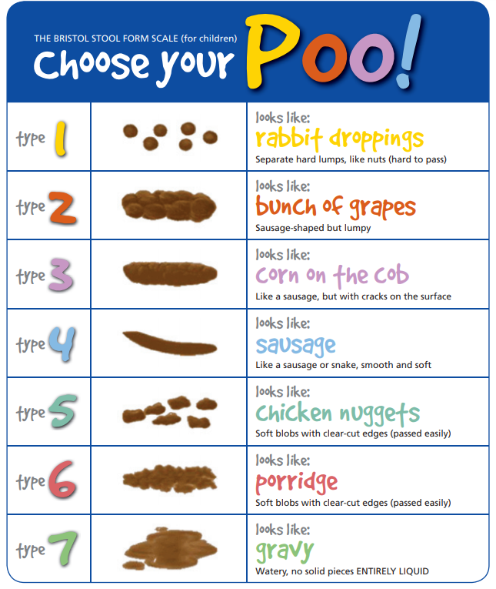

**N.B All sections of this document must be completed fully alongside the referral document. Failing to do so will result in the referral being rejected.**